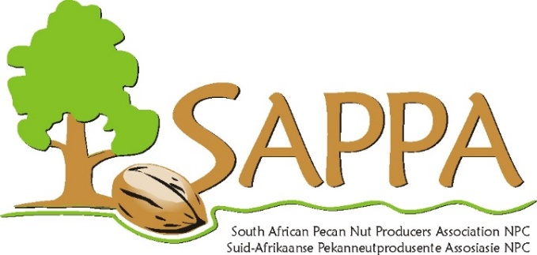
AJV & Inligtingsdag - Uitstalling
AGM & Information day - Exhibitions
9 & 10 November 2018, Cradock
Besonderhede vir uitreik van faktuur/ Billing details

Entiteit verantwoordelik vir betaling/ Paying entity
Posadres / Postal address
BTW no./ VAT no
Sel / Cell
E-pos / Email

Please mark the relevant boxes/ Merk asb. watter opsie van toepassing is.
Type/ Tipe | Fooi (BTW uitgesluit)  Fee (excluding VAT) | Sluit in/ Includes
Exhibition (±18m² ) | R3000.00 | Stand  Company name will be printed in the program of events.  Advertisement in Goodie Bag,
Sponsor refreshments/ meal | R2000.00 | Company name will be printed in the program of events.  Advertisement in Goodie Bag
Business card/ Pamphlet (advertisement) in Goodie Bag | R1000.00 | Advertisement in Goodie Bag

Invoices will be issued according to the type of sponsorship. Should you require more space or have specific requirements please contact us at sappa@hortgro.co.za
Fakture sal uitgereik word volgens die tipe borgskap. Indien u ’n groter spasie benodig of spesifieke navrae het kontak ons gerus by sappa@hortgro.co.za

