Fungi associated with pecan diseases in South Africa

Gert J Marais
Department Plant Sciences, University of the Free State, Bloemfontein, 9301, RSA
maraisgj@ufs.ac.za

The University of the Free State, in collaboration with The South African Pecan Nut Producers Association NPC (SAPPA) embarked on a study at the end of 2013 on the diseases of pecan nuts, with the emphasis of identifying and evaluating fungal diseases. This project is now coming to an end at the end of 2016, and provided important information on the variety of fungi associated with pecans, and the ability of some to cause disease in pecans. It is clear through this study that what previously was thought to be the causative agents of pecan diseases was not a true reflection of the actual problems faced by producers.

During the past three years a survey was done where fungi were isolated from nuts, stems, leaves, roots, soil, insects, and air, and it was found that at least 110 different fungal species are associated with pecans in South Africa. These fungi range from mainly saprophytic fungi that live on dead organic material to well-known plant pathogenic species. But it is only a small portion of these fungi that can be regarded as potentially pathogenic to pecans. From the list of fungi, six groups have been identified that could potentially play a significant role in pecan diseases. These include Cladosporium, Alternaria, Neofusicoccum, Neocosmospora, Chaetomium, and Fusarium species.

Cladosporium species

Prior to this study, farmers from the Hartswater area have frequently claimed that they experienced pecan scab. This disease is mainly found in certain parts of the south-eastern USA, caused by a fungus called Fusicladium effusum (previously known as Cladosporium caryigenum). Symptoms include light brown circular lesions on stems, leaves, shuck and nuts. Initial spots appear olive-green that turn black as they age.

The UFS/SAPPA study indicated that what the farmers in Hartswater perceived as scab was actually symptoms of a combination of anthracnose and black blotch. However, during the 2014/2015 season, samples from the Limpopo Province and Kwazulu-Natal indicated typical symptoms of scab. Molecular analysis indicated that the scab was caused by Cladosporium cladosporioides and not Fusicladium effusum as experienced elsewhere in the world. Studies also indicated that this fungus is constantly associated with the presence of the pink mold, Trichothecium roseum. It was also found that C. cladosporioides mainly grow superficially, penetrating only the upper layers of the nut, but it seems to open the door for T. roseum to colonise and cause damage deeper inside the nut.

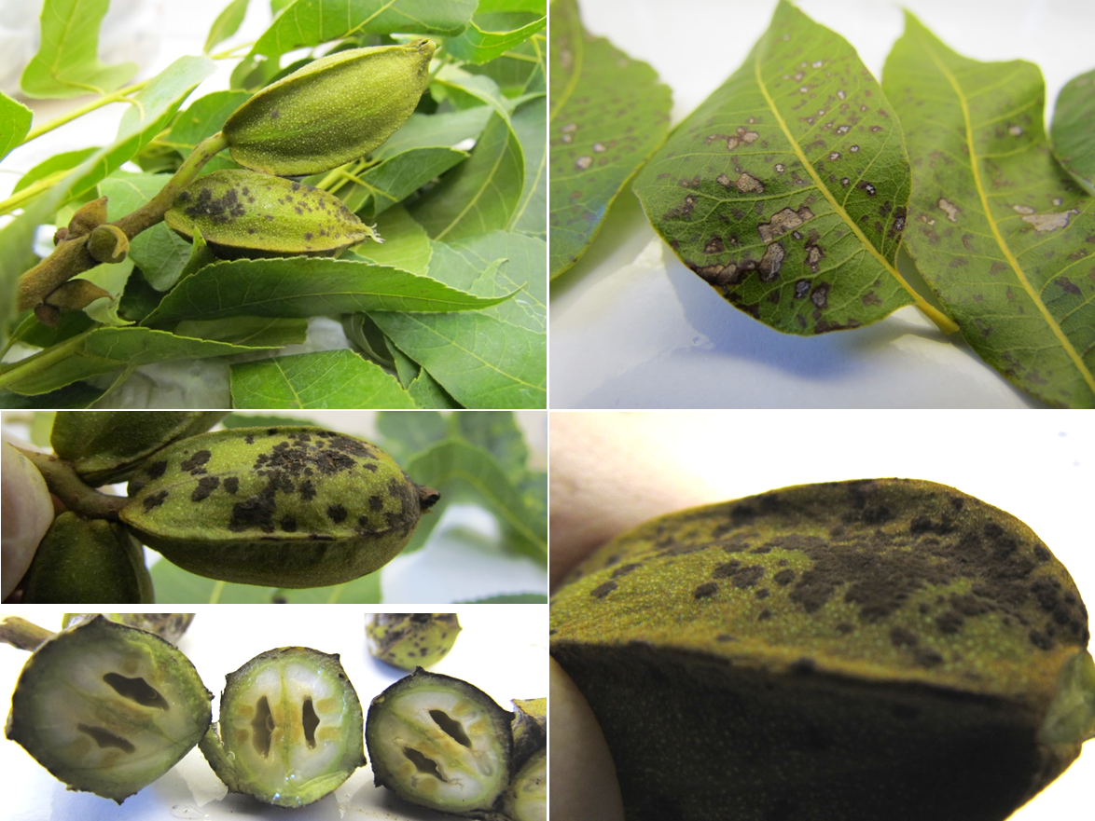
Figure 1: Pecan scab caused by Cladosporium cladosporioides in the Limpopo Province.

Alternaria species

Alternaria tenuissima is constantly isolated from diseased, as well as apparently healthy, plant parts of pecans. This fungus is known to occur as an endophyte in plants without causing any disease symptoms, but when plants seem to experience stress due to external factors the fungus can become aggressive and cause disease. It was shown in this study that A. tenuissima is the causative agent of anthracnose on pecan nuts, causing sunken black lesions. This fungus is also capable of causing leave spot that is visible as a brown circular necrosis. It has also been isolated from pecan trees showing die-back. Alternaria tenuissima was found in all the pecan growing areas in South Africa, and in almost all pecan samples analysed over the last three years, indicating that this fungus is omnipresent and likely already present when young pecan trees are planted in the field from nursaries.

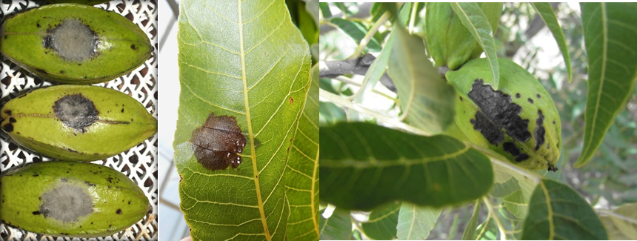
Figure 2: Alternaria tenuissima causing anthracnose in pecans.

Neofusicoccum species

Pathogenicity tests on Neofusicoccum parvum indicated that this fungus cause black blotch on pecan nuts, with the capability to blacken the whole nut within 9 to 14 days after infection is initiated. In addition, this fungus also cause brown necrosis on leaves that seemingly run between veins, giving the lesions a square appearance. This fungus is also constantly isolated from pecan trees with die-back symptoms. Another closely related fungus, Neofusicoccum vitifusiforme, was isolated from blue stain in the stems of pecans. Whether this fungus was the primary causative agent of blue stain still needs to be confirmed. According to scientific reports, N. vitifusiforme can cause similar symptoms as N. parvum and has been isolated from grape vines in Italy, causing die-back.

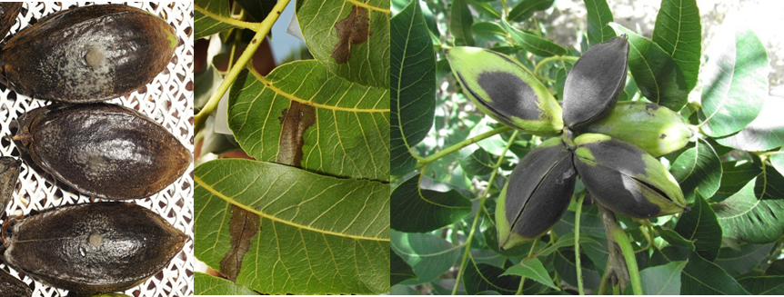
Figure 3: Neofusicoccum parvum causing black blotch in pecans.

Neocosmospora species

Neocosmospora vasinfecta was found to occur in a number of leave and stem samples analysed in the 2014/2015 and 2015/2016 seasons in the Vaalharts area. This fungus is an important plant pathogen on a number of plant crops including root rot and stem rot of soybean and peanuts in the USA, Vietnam and China, as well as wilt disease of cotton, watermelon and cowpeas. Preliminary pathogenicity tests in this study indicated that this fungus aggressively infect pecan nuts, causing black lesions. A new species, Neocosmospora rubicola, was described in 2015 by scientists in the Netherlands. It was at the same time that this fungus was isolated from the stems of pecans in the Vaalharts area from blue stain lesions and roots. The role of these fungi in pecans in South Africa needs to be determined yet.

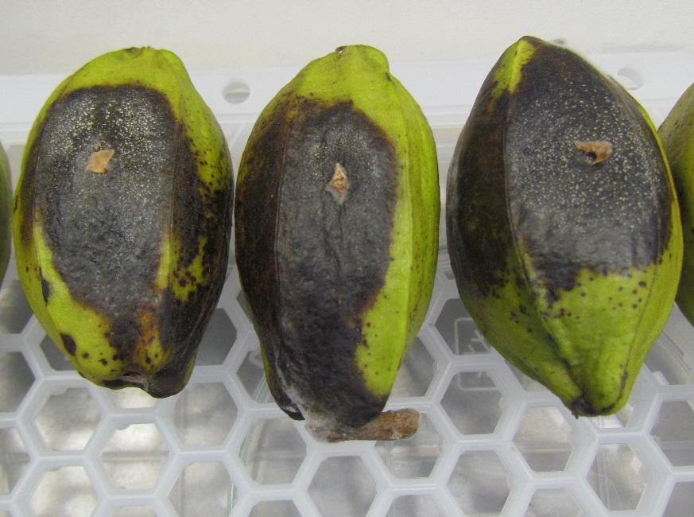
Figure 4: Infection of Neocosmospora vasinfecta after 14 days incubation.

Chaetomium species

At least 5 morphologically different species of Chaetomium have been isolated from diseased nuts, leaves and stems of pecans. Although these fungi are rather known as lignin degraders of dead plant material, preliminary pathogenicity tests indicated that they can cause black lesions on pecan nuts. However, the exact role and full potential as pathogens in pecans still needs to be established.

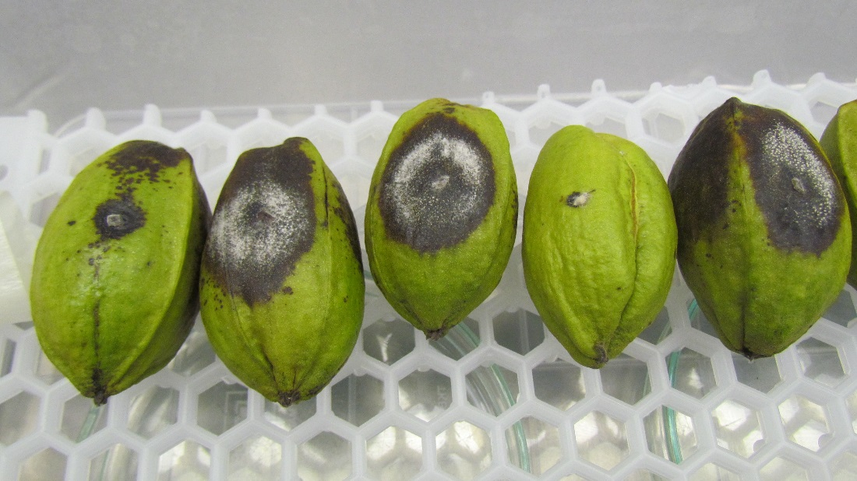
Figure 5: Chaetomium sp. causing black lesions on pecan nuts after 14 days.

Fusarium species

In this study, a number of Fusarium species were isolated from pecans in South Africa. These include the Fusarium oxysporum complex, F. equiseti, F. falciforme, and F. solani. These fungi were mainly isolated from the stems and roots of diseased pecans in the Vaalharts and Prieska areas. Their role and their ability to affect the health of pecans still need to be investigated, but pathogenicity tests indicated that these fungi have the ability to infect pecan nuts, causing white overgrowth.

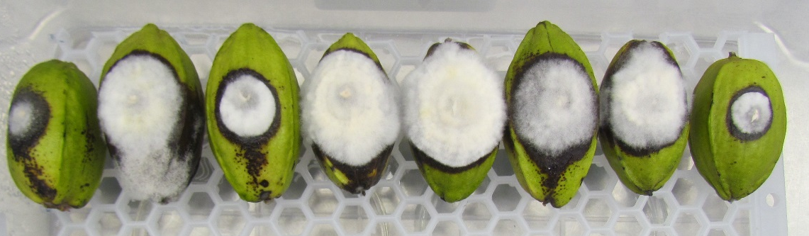
Figure 6: Infection of Fusarium sp. causing white overgrowth after 14 days incubation.

Although a tremendous amount of information has been gathered over the last three years, we are only now starting to unravel the varietey and extent of fungal species associated with pecans and their role in the health of these trees in South Africa. How to control and manage these diseases are not yet at a point where we have all the answers, but there are certain actions that a farmer can take to combat fungal diseases in the orchards. Some of these include:
- Alternaria tenuissima is an endophyte and is therefore present in all plant material. It is only when the plant is under stress that it seems to cause disease symptoms. To control the effect of this fungus a farmer should rather act preventative by keeping the plants healthy through good agricultural practices including nutrition, soil health and controlling drought stress. Alternatively, systemic fungicides can be used.
- Neofusicoccum parvum is mainly associated with die-back and seems to be more aggressive when wounds have been caused through physical means. Dead or infected branches should be cut from the tree and physically removed from the orchard to prevent further spread.
- Cladosporium cladosporioides that cause scab seems to be mostly superficial on nuts, but it opens the door for other pathogens such as Trichothecium roseum. The use of contact fungicides in areas where scab tend to occur should be used as a preventative measure. After infection has been established it is difficult to kill the fungal growth inside the plant material.
- The presence of most fungi seems to be connected to stresses in the plant due to external factors. If these stress factors can be identified and be addressed, fungal levels will decline and can be controlled.

Findings of this study emphasised that we are only now beginning to understand the pathogenic challenges on pecans in South Africa. We have unique pathogens that have not been seen to affect the health of pecans elsewhere in the world. Many of the fungi that have been found to be prominent in South African pecans, and have the potential of causing disease are new reports. This makes it difficult to look at other parts of the world for solutions to control these diseases, and we need to find unique ways that will work in the South African context. This will only be possible if we understand the complexity and interactions of these pathogens with their hosts and the environment, which form part of the next phase of research planned for the next five years. The overall health of pecan plants seems to have a significant impact on the ability of fungal pathogens to cause disease and, therefore, the focus will be to understand these interactions.

