Orchard design – Preparation for sunlight management

Orchard layout
- The focus when doing the initial orchard layout should be on future sunlight management.
- Why is sunlight management so important?
- Along with water management, sunlight management is the most important factor for producing good crops of quality pecans.
- Alternate bearing, with lower quality in the on-year, becomes a major problem in overcrowded orchards.
- Pecan trees only produce on the leaf surface in the canopy were direct sunlight can penetrate.
- If trees are left to overcrowd completely only the rooftop of the orchard will produce, which will reduce your bearing surface considerably.
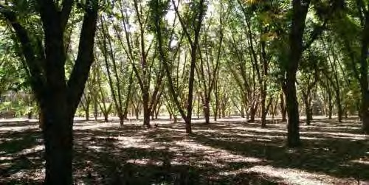

Sunlight Management
How will sunlight be managed over the lifetime of the orchard?
- Some of the possible management tools available are as follows:
  - Hedge pruning
    - The trees are cut back in the form of a hedge row to open up space between the tree rows.
    - This is mostly done with heavy equipment that needs space to turn at the end of the orchard row.
    - Hedge pruning must be done in a cycle were trees are cut on the sides and on the top every 3-4 years.
    - Hedge pruning can be very effective but is expensive.
    - If done correctly, hedge pruning will increase quality, reduce the effect of alternate bearing and may increase the average yield.

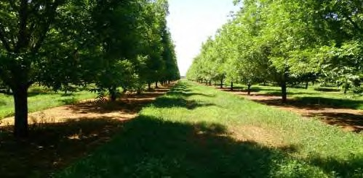

  - Selective limb pruning
    - Cut open a window into the tree’s canopy to let sunlight into the tree.
    - Large limbs are cut back flush at the nearest large crotch or fork, this will prevent excessive regrowth, while still allowing sunlight into the tree canopy.
    - This is done by hand with the help of pruning towers and is a labor intensive process.
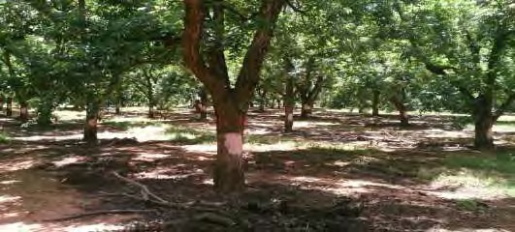
  - Tree thinning
    - Alternate trees are taken out once the first branches touch, but before they start to crowd each other. Tree removal can be done in different patterns.
    - Tree removal should be done before an on year, to reduce the effect of a lower crop the following year.
    - If done correctly, tree removal should not have an effect on yield and may reduce alternate bearing, resulting in improved quality.
    - With the first thinning tree numbers can be reduced by up to 50%.

    - With the final thinning, trees can be reduced to 25-32 trees per Ha.
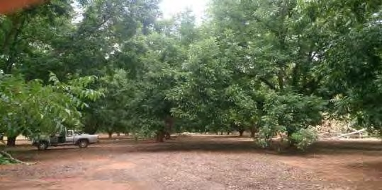
- The light management strategy that will be implemented, when the trees start crowding, will impact on the initial layout of the orchard.

Orchard design – General considerations
- Cultivar rows should be planted in a North South direction for the best light management options.
- The denser the tree spacing, the faster the trees crowd.
- The dominant wind direction during the pollination period, in South Africa mostly during October, should be considered when the cultivar layout is done.
- Different cultivars should not be planted further than 50m apart from each other, for better crosspollination.
- Enough space needs to be left open at the end of the orchard row for machinery to turn if heavy pruning equipment or mechanical harvesting equipment will be used. Even basic spraying equipment needs space to turn around the last tree in the tree row.
- Terraces on the field will influence the orchard layout, block sizes and possible sunlight management strategy.
- For mechanical harvesting the soil must be leveled, preferably before orchard establishment.
- When using flood irrigation the slope will determine the working direction in the field and should be laser leveled before planting.
- The irrigation system needs to adapt to the orchard layout and not the other way around. It must allow you to work in a North South direction if mechanical hedge pruning is considered.
- If planting in a North-South direction you can plant either in a square or in a rectangular pattern, if planting in any other direction a square planting pattern should be followed.
- For easier harvesting, your cultivar rows should follow your working direction of the orchard.

Examples of tree spacing

Distance between trees |  | Trees per hectare
Between rows | In row
10 | 10 | 100
10 | 8 | 125
10 | 7 | 143
10 | 5 | 200
12 | 12 | 69
12 | 10 | 83
12 | 8 | 104
12 | 6 | 139
14 | 14 | 51
14 | 7 | 102

A rectangular planting pattern should only be considered if both your cultivar rows and you working direction are North-South. A North-South direction gives maximum sunlight penetration in an orchard planted in a rectangular pattern, or if trees are hedged in a North-South direction.
Planting closer than 8m apart in the tree row, should only be considered if mechanical hedge pruning is an option. With selective limb pruning or with tree removal, a closer spacing may be a waste of resources, as trees may have to be removed before they have paid for their own establishment cost.

