Bollworm Damage

It has come to our attention that in certain areas producers experience damage from African bollworm and we urge growers to scout before they start spraying for the pest but to also inform SAPPA or myself Hardus du Toit, 083 465 6522 or sappahardus@gmail.com of the problem. Areas where it has been found in orchards include Vaalharts, Prieska and Modimolle.

African bollworm (Lepidoptera: Noctuidae) (Afr: Afrika bolwurm)
Identification and seasonal occurrence
The moth (adult) stage of the bollworm, Helicoverpa armigera, has a light golden-brown appearance with an open wingspan of 35-40mm. A slightly darker band stretches across the wings with a darker spot in the middle of each.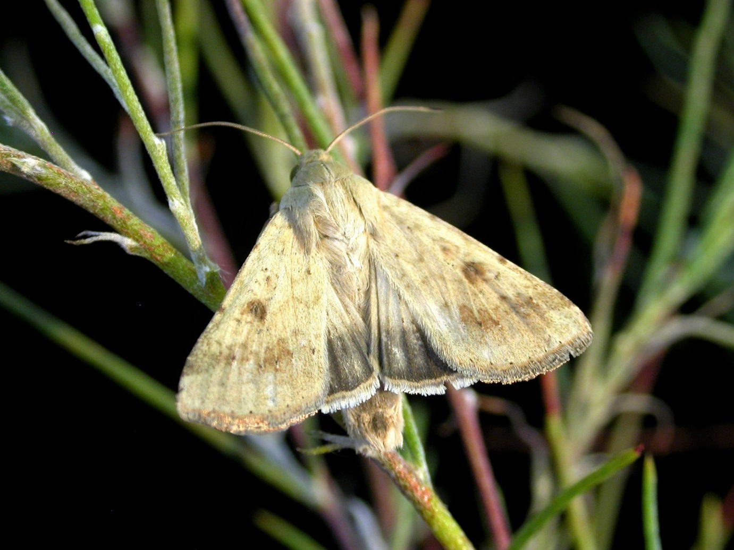

Larvae can reach 40mm in length and show considerable colour variation, ranging from yellow-green to almost black. A longitudinal whitish stripe extends along the side of the body, a characteristic feature of this insect (Bennet, 2015). Note: this insect is often incorrectly referred to as the American bollworm, which is a different species (Helicoverpa zea; corn earworm) found in the Americas.
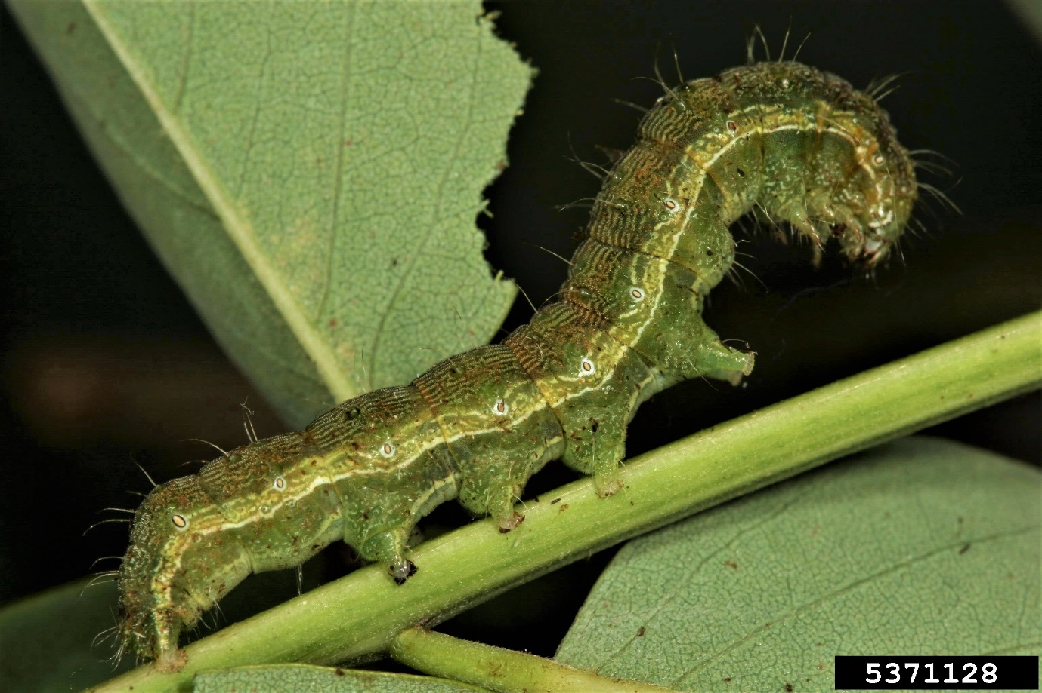
Damage and control
Larvae of H. armigera form part of a complex of lepidopteran species recovered from pecan trees during October / November. During this time (i.e., initial nut expansion that follows fertilization and embryo development), small developing nutlets are targeted by young H. armigera larvae. The larva creates a characteristic round entry hole in the nutlet, feeding on its contents and arresting all further development.
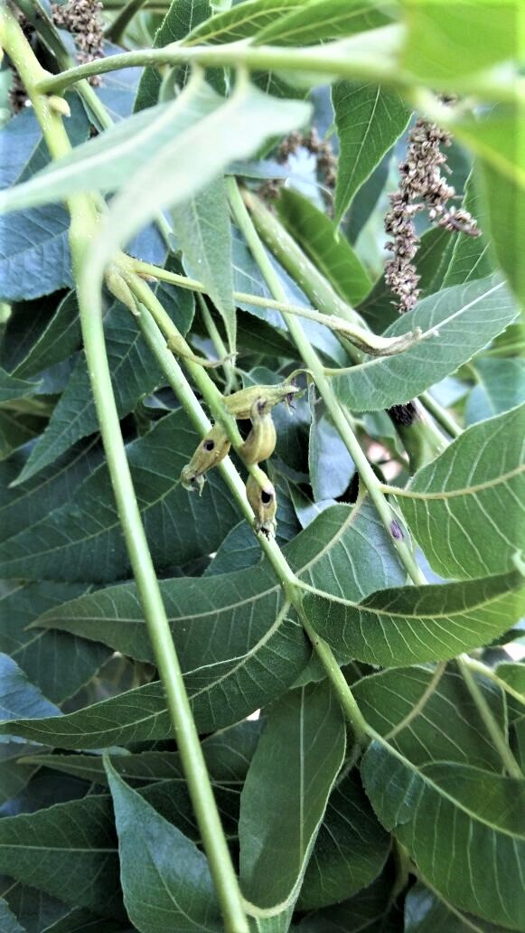
This insect is highly polyphagous and its prevalence in pecan orchards may be governed by the presence of other suitable host plants in the area. The deployment of pheromone traps should indicate moth activity and the risk associated with subsequent larval feeding. For remedies registered against African Bollworm on pecan, see the list of registered products on the SAPPA website.
Information supplied by Dr Justin Hatting ARC Bethlehem

