Quantifying water use of mature pecan orchards in selected irrigation areas of the Northern Cape – research report
NJ Taylor, JG Annandale, A Sanewe, W Rossouw, S Kunene, M Zwane, E Lötze, A Clulow & CS Everson


In April 2018 a five year project on pecan water use began, which is jointly funded by the Water Research Commission and SAPPA. The University of Pretoria is the lead organisation and is collaborating with the University of KwaZulu-Natal and Stellenbosch University. The main aim of this project is to quantify the water use of mature orchards in the Vaalharts and Upington regions and to determine the impact of water stress at different phenological stages on the yield and quality of pecans. A preview of the project appeared in Volume 80 of the SA Pecan and this report provides an update of progress to date. Measurements of water use in Vaalharts began in September, whilst the water stress trial began in September 2017.

The water use measurements are being conducted on a farm 20 km west of the town of Jan Kempdorp in a 12 year-old mixed cultivar orchard. In this orchard we are measuring transpiration of four ‘Wichita’ and four ‘Choctaw trees, together with soil water content, depth of the water table with a piezometer, soil evaporation, canopy cover and weather variables (Figure 1 and 2). The orchard has recently been changed to full surface irrigation (wetted radius of 6.5 m) using 150 L h⁻¹ Mamkad 16 sprinklers (NaanDanJain Irrigation) and a vegetation cover is being established in the work row. As these measurements only began two months ago there is no significant data yet and final water use data will only be available near the end of the trial. We aim to measure water use in this orchard for at least three years. 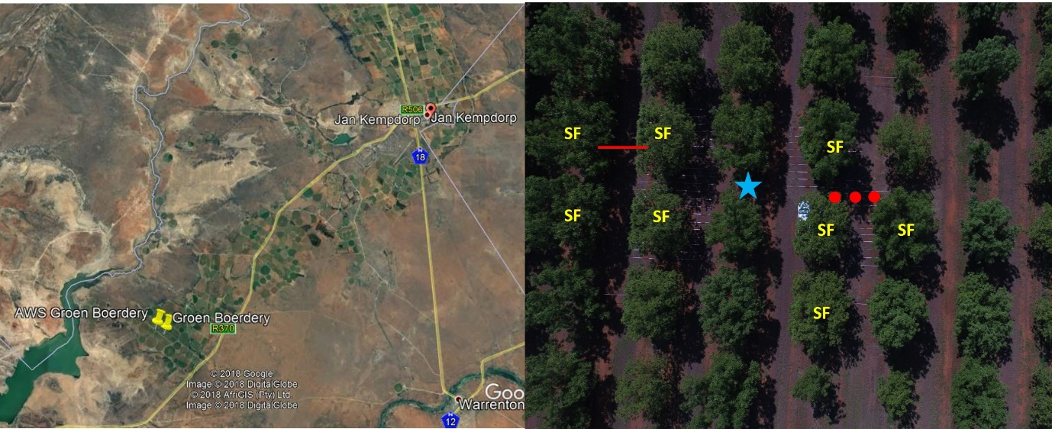
Figure 1 Location of the study site in the Vaalharts region and the experimental layout in the mature pecan orchard. SF indicates the trees in which sap flow is measured. The red line indicates where the soil water content of the topsoil is measured. The red dots indicate where soil water content down the profile is measured. The blue star indicates the location of the piezometer for determining the level of the water table.
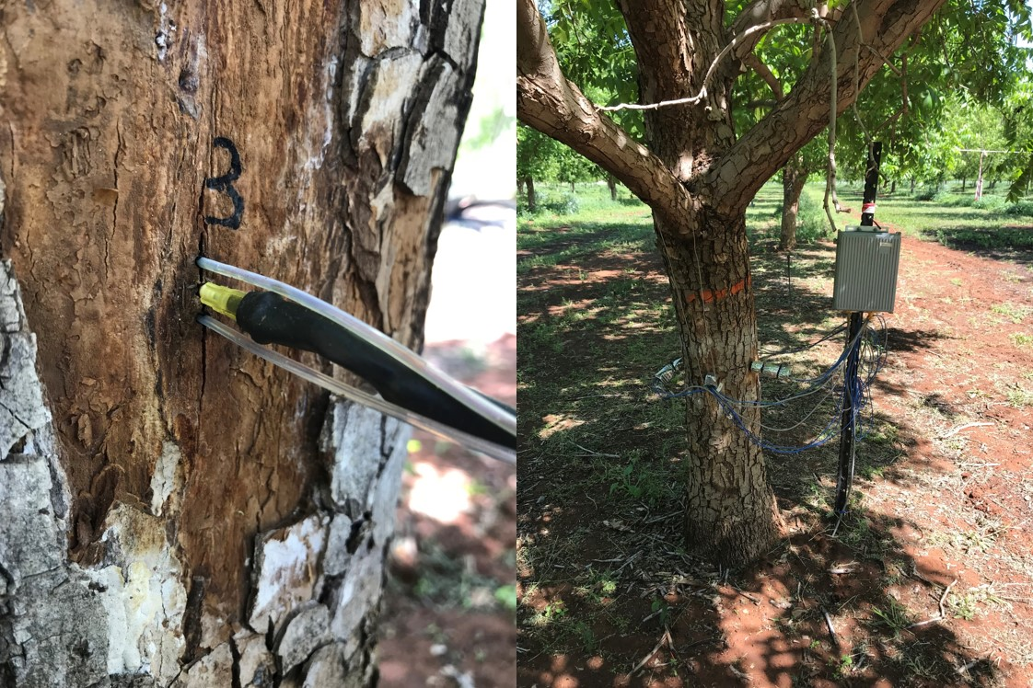
Figure 2: Sap flow system used to determine transpiration of the pecan trees

At the end of the trial we hope to be able to answer the following questions. How much water do mature ‘Wichita’ and ‘Choctaw’ trees use in a day and over the entire growing season in the Vaalharts and Upington regions? How does water use change with changing environmental conditions, canopy size and canopy development? Based on canopy size and local conditions how much water will your trees use in a month and over the season? What is the water use efficiency (kg m⁻³) and water productivity (R m⁻³) of pecans?
In order to quantify changes in canopy size over the season and between trees we are using RGB images taken with a drone and a cell phone app Canopeo to determine canopy cover (Figure 3). This will be very important for estimating water use of orchards across South Africa, as water use is largely determined by canopy size and local weather conditions. The accuracy of these measurements is being assessed on the University of Pretoria’s Experimental Farm.

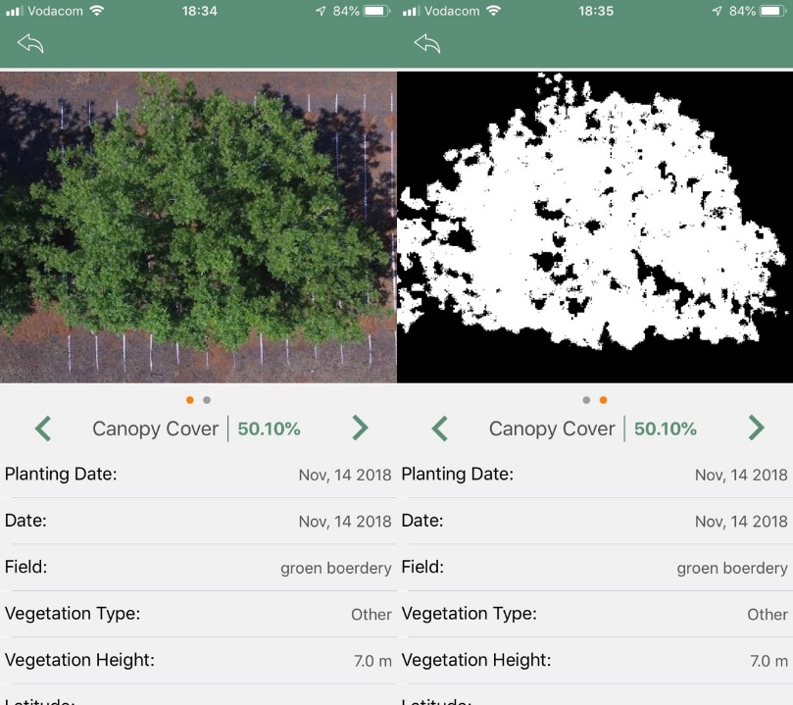
Figure 3 The Canopeo app used to determine the canopy cover of pecan orchards
We have managed to complete one full season of measurements on the water stress trial being conducted on the University of Pretoria’s Experimental Farm. A mild water stress will be implemented at four phenological stages, which are flowering and nut set, nut sizing, nut filling and shuck dehiscence. These treatments will be compared to a well-watered control, with irrigation scheduled by monitoring soil water content and pre-dawn leaf water potentials. Results from the first year of measurements showed that yield was reduced when stress was induced during flowering and fruit set and nut filling, but there was no significant effect on yield during nut sizing or shuck dehiscence (Figure 4A). The reduction in yield was most likely a result of reduced nut number rather than nut size, as during the first season there was no impact on nut size in the different water stress treatments (Figure 4B). Further seasons of data are required to fully understand the impact of water stress on pecan yield and quality, due to the perennial nature of the crop, together with its alternate bearing nature. From this trial we hope to gain an understanding of how pecan trees respond to slight stress and how this differs between phenological stages. This information can then be used to determine when during the season water savings can be made, which will be particularly important during drought periods when water allocations are reduced.

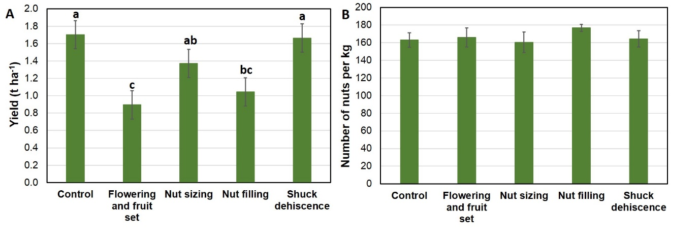
Figure 4 The impact of water stress at different phenological stages on A) yield and B) nut size of pecans

The first 7 months of the project have progressed well and we will continue to collect data in Vaalharts and in the orchard on the Experimental farm for at least three years. Water use of orchards in the Upington region will begin in 2019 and will also continue for three years. Measurements of water use in the hotter growing regions of South Africa will be critical for updating an existing model of pecan water use and making it applicable to all pecan growers in South Africa.

Acknowledgements
The WRC directs, manages and funds this project (Project number K5/2814//4) together with co-funding from SAPPA. The project team would like to thank in particular Dr Gerhard Backeberg and Dr Sylvester Mpandeli for initiating and managing the project. Hardus du Toit and Ivan Schubach from SAPPA provided invaluable help in selecting the site and during the initial equipment installation. We would also like to thank Marnus Groenewaldt from Groen Boerdery for allowing us to work in his orchard and for all the continuous help. Albert Bouwmeester has assisted us with all the pecan quality assessments from the water stress trial.

