  - National Mapping of Pecan Orchards in South Africa
Date: 30th November, 2023
Institution: Applied Agricultural Remote Sensing Centre (AARSC), University of New England (UNE), Australia
Principal Investigator: Craig Shephard Sub-Investigators: Abbie Rankin, Andy Clark, Blake Morrison
Other Personnel: Andrew Robson, Sophia Clark
Project Start: July 2023 Project completion: December 2024

Summary

The total production area of pecan orchards currently published in the SAPPA Industry Engagement Web App (IEWA) is 23,431 hectares (ha). The IEWA was last updated on 17th October 2023, Table 1 presents the total area of pecan orchards, summarised by each SAPPA region.

Table 1: Total production area of pecan orchards as published in IEWA
SAPPA Region  (by priority order) | Mapping Stage  (at November 2023) | Area (Ha)
5 | Draft & Field validated | 1,347
8 | Draft | 15,645
9 | In Progress, partially field validated | 1,163
6 | In Progress | 1,024
4 | In Progress | 2,747
7 |  | 173
3 |  | 205
2 |  | 918
1 |  | 209
Total |  | 23,431

Mapping methodology
The national mapping of South African pecan orchards is being undertaken progressively by SAPPA region, based on a 1:50K standard map tile grid (Figure 1). Regions 5 and 8 have been completely drafted, with field validation completed in region 5 and partially in region 9. Mapping compilation is currently in progress for regions 4, 6 and 9.
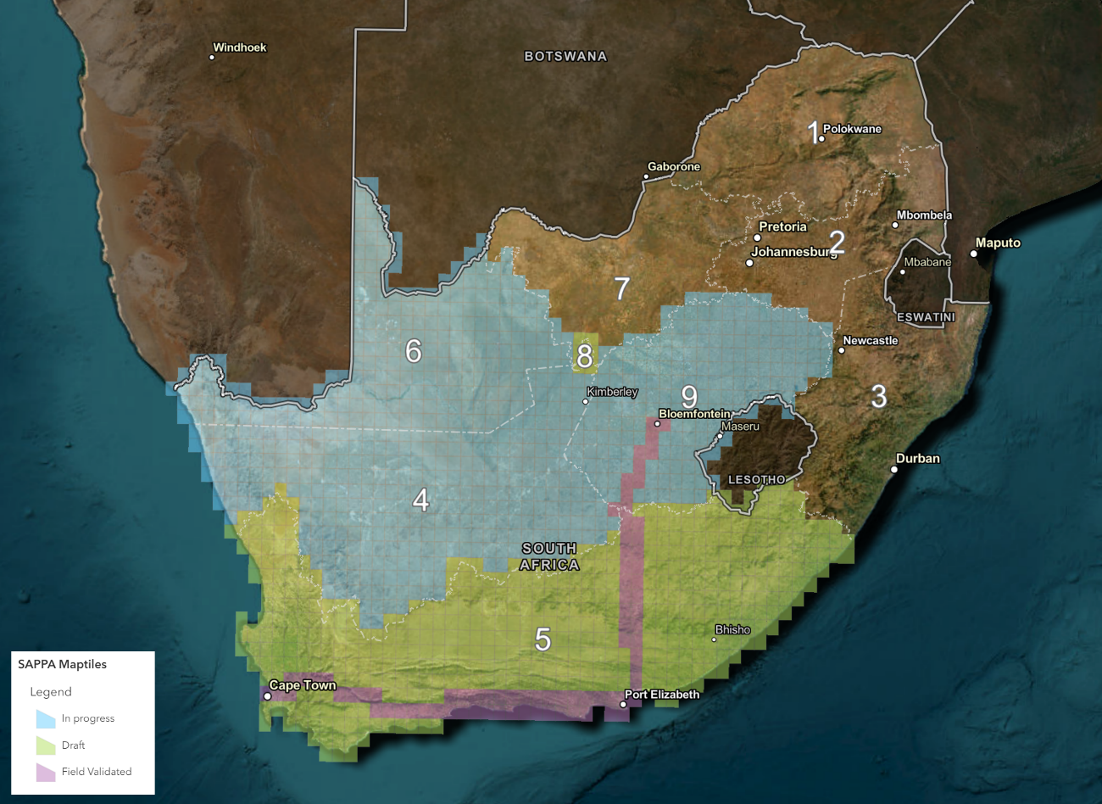
Figure 1: Mapping program progress by SAPPA region (1:50K map tiles)
Mapping compiled within a Geographic Information System (GIS), uses polygon features to delineate the location and area of each commercial pecan orchard (minimum mapping unit of 1 ha and a width of 25 m). Key attributes including the year of observation (currency) and certainty (confidence of the mapped feature) are also recorded for each feature.
Publicly accessible imagery (e.g., Google Earth, Esri Basemaps and Google Street-view) provides the primary source of high-resolution data for identifying and subsequently mapping pecan orchards. On occasion the imagery is very recent (less than 1 year old), however elsewhere the image acquisition date effectively limits the temporal currency of the map as it can be up to 3 years old. To overcome this limitation, AARSC access a time-series of satellite imagery (e.g., Planet)—which is very current (< 1 week old), but of a coarser resolution (3 m). Note that this imagery is not suitable (too coarse) for mapping new plantings. Classifying pecan orchards (from other tree crops) is also achieved by defining the key phenological growth stages from time-series (temporal) satellite imagery. Leaf drop across pecan orchards is evident from end-of-May through to June (Figure 2), which very much distinguishes these orchards from citrus or avocado.
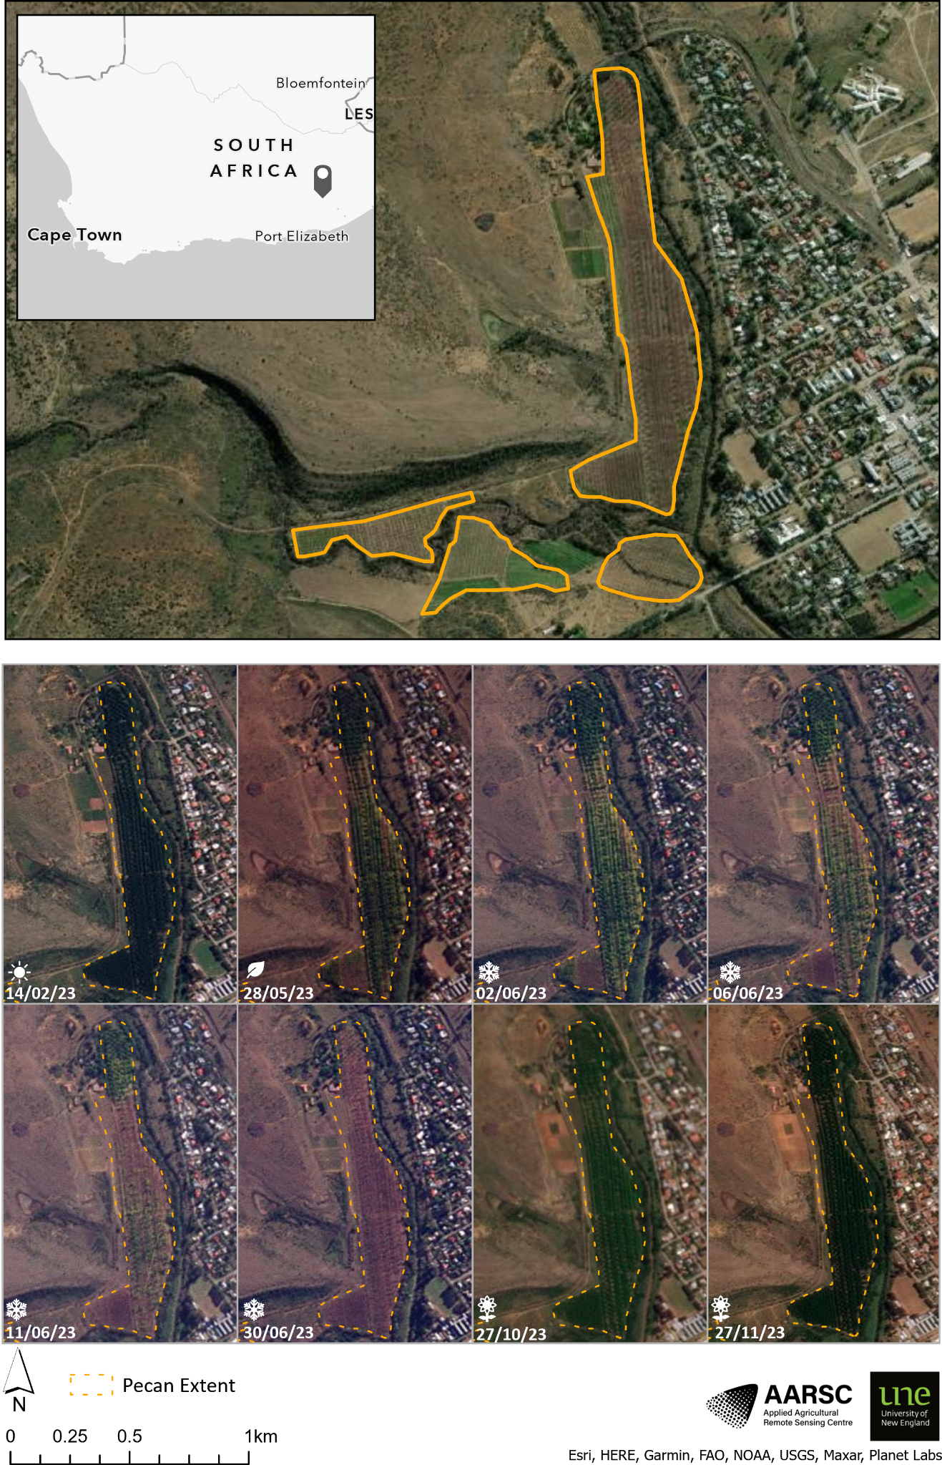

Figure 2: Pecan orchards (Adelaide, Eastern Cape) showing seasonal satellite imagery (Planet time-series)

Industry Engagement
The SAPPA Industry Engagement Web App (IEWA) enables people external to AARSC (i.e., industry) to review the draft map and provide their feedback directly to the mapping team (Figure 3). Since launching on the 23rd August 2023, the IEWA has been viewed (opened) 246 times.
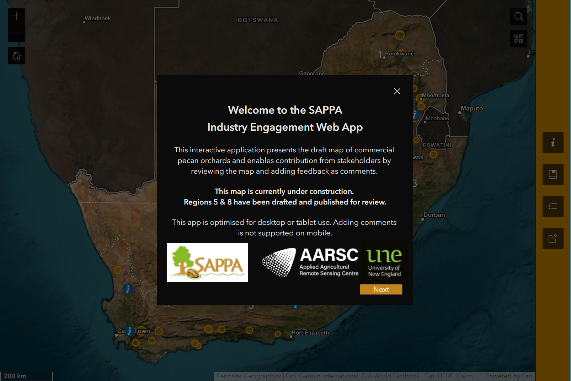
Figure 3: SAPPA Industry Engagement Web App (IEWA)
AARSC provide a response to each comment received, which is available within the app as a pop-up:
- Pending: the comment has yet to be assessed by the team.
- Assessed: the comment has been assessed by the team and will be added to the map in next update.
- Updated: the comment has been assessed by the team and published.
For this milestone, AARSC have received 153 feedback comments, including 140 points (location only) and 13 polygons (location and extent) (Figure 4). Each comment is interpreted and assessed by the mapping team and actioned as an update to the map, including a response. Figure 5 shows an example for a new planting (polygon comment) that has been ‘assessed’ by the mapping team. This update will be published into the IEWA map in the next update cycle.

Table 2 presents the analysis of all the IEWA comments received, with some 1,904 ha of pecan orchards added to the map, based on the feedback submitted from industry engagement.
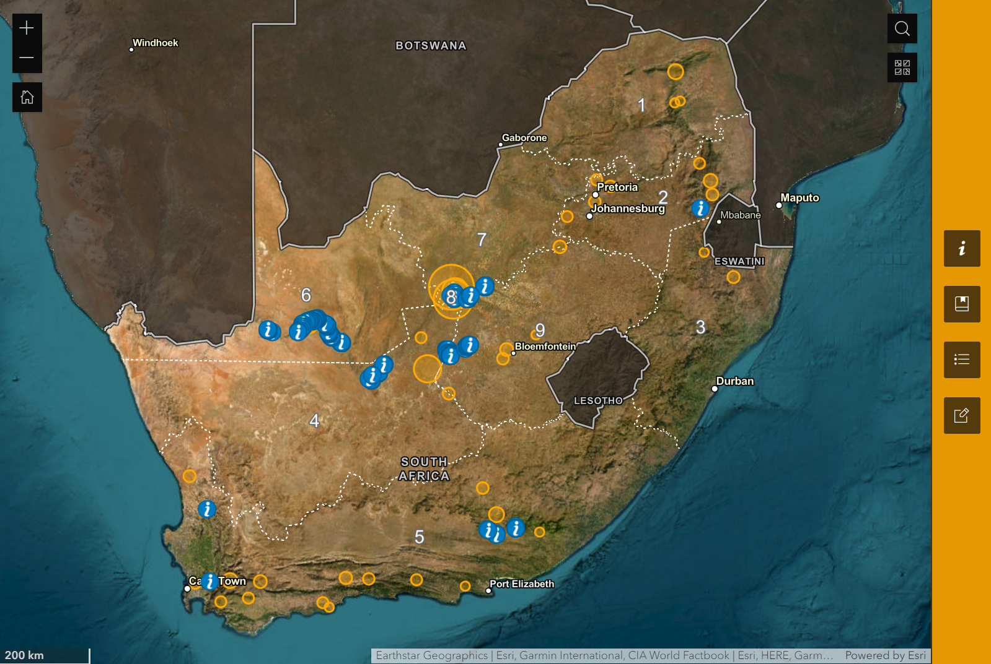
Figure 4: SAPPA IEWA comments received

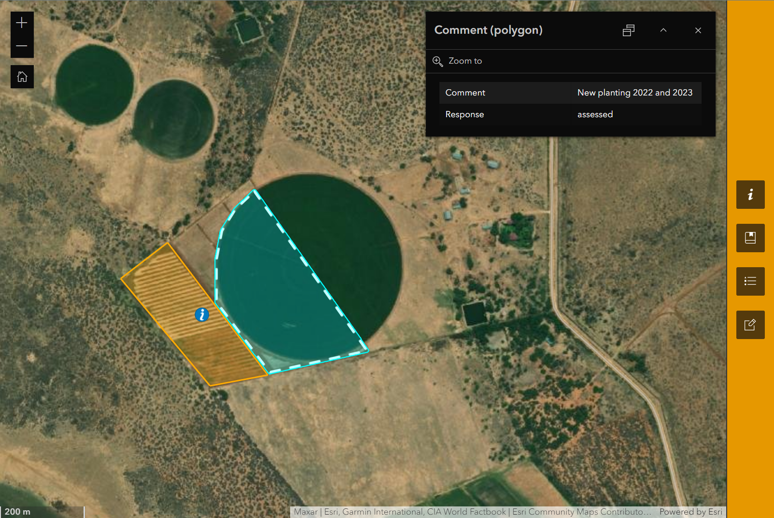
Figure 5: IEWA comment for new planting

Table 2: SAPPA IEWA Comments analysis
SAPPA Region | Comments count | Area added  (ha) | Area confirmed (ha) | Area removed  (ha)
1 | 0 | 0 | 0 | 0
2 | 4 | 40 | 0 | 0
3 | 0 | 0 | 0 | 0
4 | 22 | 187 | 0 | 0
5 | 13 | 0 | 133 | 0
6 | 58 | 469 | 0 | 0
7 | 1 | 4 | 0 | 0
8 | 15 | 14 | 205 | 0
9 | 40 | 1,191 | 0 | 0
Total | 153 | 1,904 | 339 | 0

Field validation
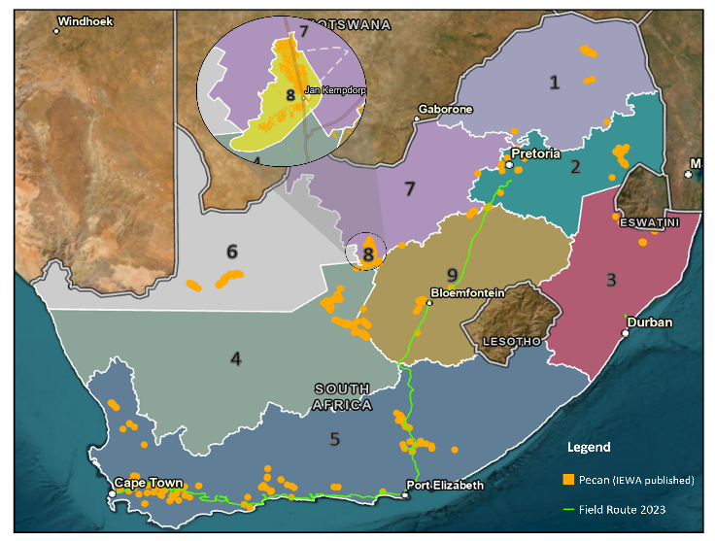
Field validation targeting areas of known uncertainty in the mapping was completed by AARSC staff in regions 5 and 9 from 24th–28th of September 2023 (Figure 6). Analysis of all the pecan orchards mapped in region 5 shows that 24% (by area) were field validated.
Figure 6: Field validation route, completed September 2023

Mapping in compilation
Mapping is currently being compiled across regions 9, 6 and 4. Analysis of the mapping to derive total area by SAPPA region is presented in Table 3 (as of 27th November 2023). Note that these metrics are subject to change as more progress tiles are drafted; additional feedback is received in peer review; and lastly field validation is undertaken.
Table 3: Mapping in compilation, total area by region

SAPPA Region  (by priority) | Mapping Stage  (November 2023) | Area (Ha)
5 | Draft & Field validated | 1,331
8 | Draft | 15,321
9 | In Progress | 5,793
6 | In Progress | 1,012
4 | In Progress | 3,633
7 |  | 359
3 |  | 207
2 |  | 938
1 |  | 200
Total |  | 28,794

Research outputs
- The Industry Engagement Web App (IEWA) enables stakeholders to review the map and provide feedback through direct comments, since launching on 23rd August 2023 the app has been viewed (opened) 246 times;
- The AARSC industry maps and applications gallery webpage (www.une.edu.au/webapps) hosts the SAPPA IEWA, within the ‘South African Tree Crops’ page;
- AARSC presented (virtually) at the annual SAPPA AGM on 21st October 2023, sharing the mapping methodology and a live demonstration of the IEWA;
- An article promoting the mapping project was submitted for the October issue of Pecan industry magazine.

Challenges Encountered
Accurately mapping new plantings is best informed via industry engagement. Stakeholders (growers) are encouraged to continue to review the map in the IEWA and provide feedback directly to the mapping team. Collaborating with industry to assist us in building the map is essential for mapping new plantings, which cannot be mapped with satellite imagery alone.

Future work
- Draft mapping will be published in the IEWA for regions 4, 6 and 9 in our next update cycle. The mapping team will also continue to action all feedback comments received via the IEWA ad-hoc;
- AARSC can assist SAPPA in ‘hosting’ the IEWA (embedding the app within an ‘iframe’) on the ‘orchard mapping section of your website (https://www.sappa.za.org/orchard-mapping). Hosting the mapping applications on industry websites has proven very successful for engaging contribution from growers. For example, view Citrus Australia’s webpage which hosts their industry map here.
- Field work is tentatively scheduled for late May 2024 for regions 9, 7, 8, 6 and 4. If SAPPA have industry field days or other event planned, the mapping team can coordinate the timing of the field validation to attend and present.

