Evaluation of paclobutrazol in pecan nut trees: FINAL REPORT ON growth, yield and residue MEASUREMENTS

IntroductioN
Paclobutrazol, a registered plant growth regulator, is commonly used on pecan nut trees in South Africa. This triazole-based compound also serves as a fungicide at different dosages. While the growth-retarding effects of paclobutrazol are well-documented on pecan nuts (Wood 1988; Andersen 1988; Worley et al., 1996), its impact on pecan yield and other parameters such as shoot growth and nut quality remains unclear (Zhu & Stafne 2019).

Some studies reported a decline in yield following single paclobutrazol applications (Andersen 1988; Worley et al., 1996). Work was conducted to better understand the long-term effects of a single or repeated application of paclobutrazol on pecan nuts in South Africa.

Paclobutrazol is commercially available for use on pecan nuts as ‘Cultar’ (Act 36 of 1947 registration no. L3693) and ‘Avocet’ (Act 36 of 1947 registration no. L7368). In this research report, the 250 g/L formulation of paclobutrazol in 'Cultar' was applied at three dosages on younger and more mature pecan trees to assess the effects of these applications on shoot growth, stem radius, stem circumference, yield, sticktights, quality, and residues. The effects after repeated (year-on-year) applications were also investigated.

Methods
Treatments were applied as a drench around the tree stems repeatedly over seasons, with the desired concentration diluted in 5L water per tree, repeated on ten data trees per treatment, tree age and farm. Organic material was removed from the application area prior to drenching. The effects of these multiple applications were evaluated on a farms with the cultivars ‘Wichita’ and ‘Western Schley’ in the Hartswater pecan nut production region, Northern Cape, South Africa.

The effects of multiple applications, repeated over seasons were evaluated on ‘Western Schley’ and ‘Wichita’. The repeated applications were 8-10 ml/tree since 2015. Reproductive and vegetative shoot lengths were measured separately during February 2022, 2023, 2024 and 2025 from four replicated wind directions (North, East, South, and West) per data tree from the top and bottom of each data tree for more uniform measures. Stem diameters and circumferences were also measured during these time points. Yields were measured during July 2021, 2022, 2023, 2024 and 2025. The weight of dropped nuts per tree, and weight and number (count) of sticktights per tree were determined per data tree. Yield quality parameters were evaluated at a processor from three grouped samples per treatment.

Statistical analysis
Data were analysed in RStudio: R Core Team (2015), v 4.2.3. Before statistical tests were performed, outliers were excluded from the datasets per treatment using the Interquartile Range (IQR) method. The IQR represents the central 50% of the dataset, between the 25th and 75th percentile of the data distribution. Outliers are identified as points 1.5 times smaller or larger than the IQR.

The main effect of each treatment (i.e. dosage) was analysed per age group as described in Patil (2021). Shapiro-Wilk tests of normality of model residuals and Levene’s Test for Homogeneity of Variance were used prior to statistical analysis with the R packages ‘ggisgnif’ (Ahlmann-Eltze, 2021) and ‘ggstatsplot’ (Patil, 2021). Results were plotted using the R package ‘ggplot’ (Wickham, 2016) after obtaining basic statistical summaries with the R package ‘Rmisc’ (Hope, 2022) to visualize statistical significance as determined with appropriate post-hoc tests on an alpha level of 0.05 (95% confidence limit). Mean and std. error (se) plots were provided using the package: ggpubr (Kassambara 2020). Statistical results of each effect were summarized in a table format using the package: Rmisc (Hope 2022) giving the sample size (N), average (mean), standard deviation (sd), standard error (se) and 95% confidence intervals (ci).

Results
Repeated applications on Western-Schley showed no significant reproductive or vegetative shoot length differences during 2024 of 2025 (Table 1). These applications did however influence Wichita shoot lengths significantly (Table 1). During 2024 the vegetative shoots were significantly longer after paclobutrazol treatments and significantly longer reproductive shoots where treatments (8-10 ml/tree) were applied and shoots were measured during February 2025 (Table 1, Figure 1).
Repeated applications significantly increase the stem circumferences and stem diameters of Western-Schley (Table 2) during both seasons’ measurements, while the stem diameters were significantly smaller after repeated treatments on Wichita based on the 2024 measurements (Table 2, Figure 2).

Repeated applications resulted in significant lower yield on Western-Schley during the 2023 harvests and Wichita resulted in significant lower yield in 2024 and 2025 harvests (Table 3). The sticktights were significantly less during the 2024 harvests of Wichita (Table 3). The total yields (natural drop plus sticktights) were significantly lower after repeated applications on Wichita for the 2024 and 2025 harvests (Table 3). Edible nut analysis results showed no significant differences between treatments after repeated applications (Table 3, Figure 3).
Table 1. Lengths of reproductive and vegetative shoots (mean ± se in cm) during February 2024 and 2025 after repeated paclobutrazol applications since 2015. Different letters indicate significance groupings per cultivar and shoot type, and sample sizes are given in brackets after outliers were removed.
Treatment |  | Reproductive shoots | Vegetative shoots
2024
Western-Schley
0 ml/tree | 9.32 ± 0.20ª (311) |  | 7.29 ± 0.23ª (275)
8-10 ml/tree | 8.81 ± 0.20ª (304) |  | 7.41 ± 0.19ª (299)
T-test results: | W_{Mann-Whitney} = 51048.50, p = 0.09 |  | W_{Mann-Whitney} = 39041.00, p = 0.30
Wichita
0 ml/tree | 8.39 ± 0.17ª (302) |  | 6.82 ± 0.23ª (263)
8-10 ml/tree | 8.64 ± 0.16ª (307) |  | 7.62 ± 0.23^{b} (297)
T-test results: | W_{Mann-Whitney} = 43994.00, p = 0.28 |  | W_{Mann-Whitney} = 34353.50, p = 0.01
2025
Western-Schley
0 ml/tree | 11.33 ± 0.25ª (302) |  | 6.27 ± 0.18ª (275)
8-10 ml/tree | 11.13 ± 0.25ª (303) |  | 6.45 ± 0.19ª (299)
T-test results: | W_{Mann-Whitney} = 46958.00, p = 0.57 |  | W_{Mann-Whitney} = 42072.00, p = 0.60
Wichita
0 ml/tree | 10.23 ± 0.23ª (302) |  | 6.17 ± 0.18ª (292)
8-10 ml/tree | 11.06 ± 0.24^{b} (307) |  | 6.69 ± 0.20ª (300)
T-test results: | W_{Mann-Whitney} = 43386.00, p = 0.02 |  | W_{Mann-Whitney} = 40234.50, p = 0.09

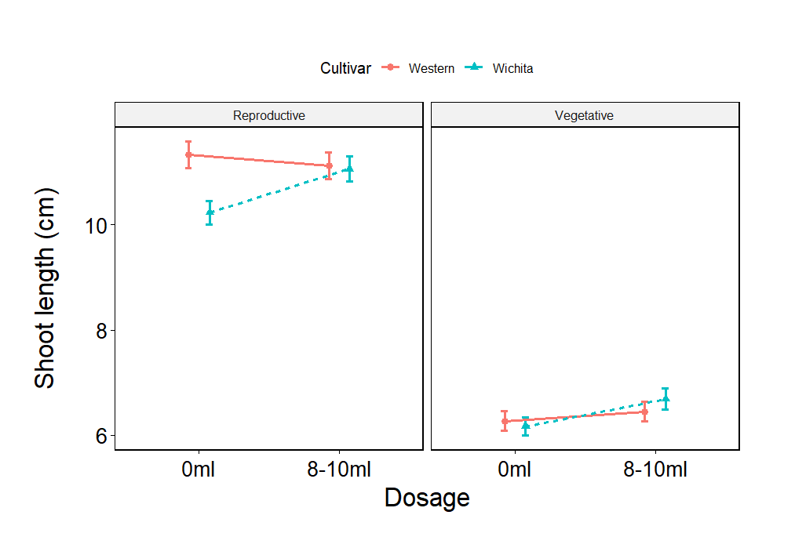
Figure 1. Lengths of reproductive and vegetative shoots (mean ± se in cm) during February 2025 after repeated paclobutrazol applications on two cultivars, Western-Schley and Wichita.

Table 2. Results from stem measurements (mean ± se cm) during February 2024 and 2025 after repeated applications from October 2015 on young Western-Schley and Wichita cultivars. Different letters annotate significant treatment differences and sample sizes are given in brackets.
Treatment |  | Stem circumference | Stem diameter
2024
Western-Schley
0 ml/tree | 87.55 ± 2.61ª (10) |  | 25.08 ± 2.57ª (10)
8-10 ml/tree | 96.64 ± 2.01^{b} (8) |  | 30.65 ± 0.54^{b} (8)
T-test results: | t_{Student} (16) = -2.64, p = 0.02 |  | W_{Mann-Whitney} = 12.00, p = 0.01
Wichita
0 ml/tree | 94.65 ± 2.91ª (10) |  | 29.95 ± 0.92ª (10)
8-10 ml/tree | 90.15 ± 3.79ª (10) |  | 28.29 ± 1.14^{b} (10)
T-test results: | t_{Student} (18) = 0.94, p = 0.36 |  | t_{Student} (18) = 1.13, p = 0.27
2025
Western-Schley
0 ml/tree | 87.88 ± 1.79ª (20) |  | 26.59 ± 1.36ª (20)
8-10 ml/tree | 95.83 ± 1.16^{b} (15) |  | 30.61 ± 0.35^{b} (15)
T-test results: | t_{Welch} (30.84) = -3.73, p < 0.01 |  | W_{Mann-Whitney} = 50.00, p < 0.01
Wichita
0 ml/tree | 94.78 ± 2.10ª (20) |  | 30.32 ± 0.64ª (20)
8-10 ml/tree | 90.58 ± 2.51ª (20) |  | 28.56 ± 0.79ª (20)
T-test results: | t_{Student} (38) = 1.28, p = 0.21 |  | t_{Student} (38) = 1.74, p = 0.09

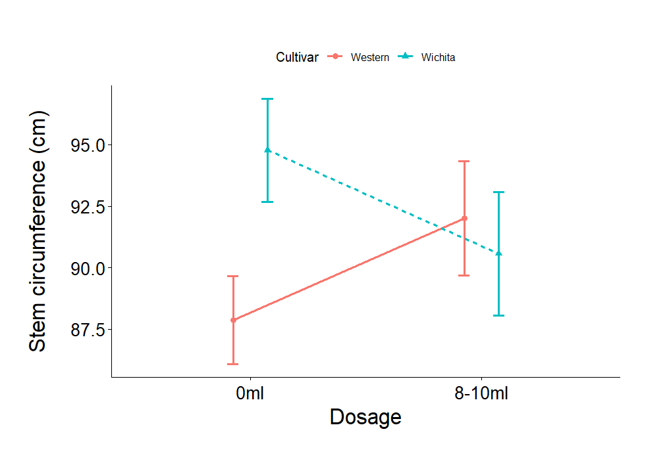
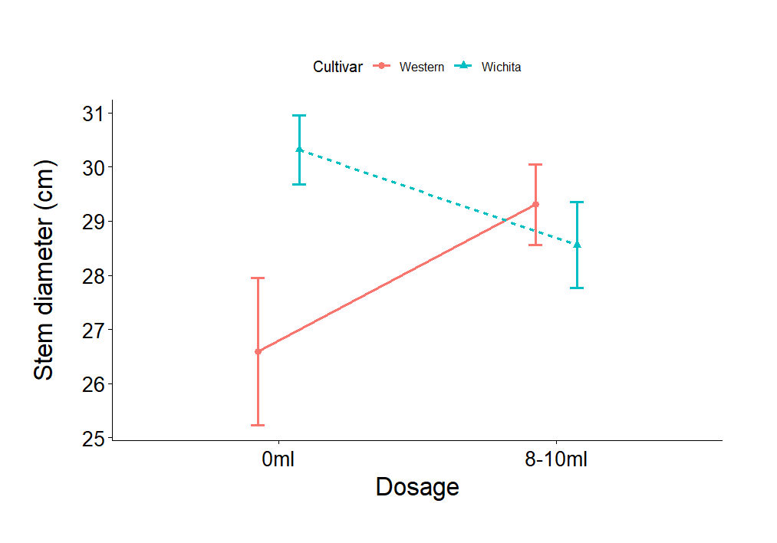

Figure 2. Stem circumference and stem diameter (mean ± se in cm) measured during February 2025 after repeated paclobutrazol applications on two cultivars, Western-Schley and Wichita.

Table 3. Yield and quality (mean ± se cm) results measured during July of 2023 and 2024 after repeated applications on different cultivars.
Different letters annotate significant treatment differences and sample sizes are given in brackets.
Treatment |  | Yield (kg/tree) |  | Sticktights (kg/tree) |  | Total yield (kg/tree) | Edible kernel (%)
2023
Western-Schley
0 ml/tree | 15.02 ± 1.46ª (10) |  | 1.22 ± 0.21ª (10) |  | 16.24 ± 1.47ª (10) |  | 57.60 ± 0.40 (2)
8-10 ml/tree | 10.59 ± 1.32^{b} (9) |  | 1.20 ± 0.20ª (10) |  | 13.20 ± 1.98ª (10) |  | 57.00 ± 0.00 (1)
T-test results: | t_{Student} (17) = 2.23, p = 0.04 |  | t_{Student} (18) = 0.09, p = 0.93 |  | t_{Student} (18) = 1.24, p = 0.23 |  | Too few replicates for analysis
Wichita
0 ml/tree | 17.65 ± 1.10ª (9) |  | 6.03 ± 0.59ª (10) |  | 23.76 ± 0.89ª (9) |  | 56.00 ± 2.50ª (2)
8-10 ml/tree | 19.40 ± 1.25ª (10) |  | 6.81 ± 0.59ª (10) |  | 26.21 ± 1.61ª (10) |  | 58.40 ± 1.60ª (2)
T-test results: | t_{Student} (17) = -1.04, p = 0.31 |  | t_{Student} (18) = -0.94, p = 0.36 |  | t_{Student} (17) = -1.29, p = 0.21 |  | t_{Welch} (1.7) = -0.81, p = 0.52
2024
Western-Schley
0 ml/tree | 33.53 ± 0.79ª (8) |  | 0.66 ± 0.06ª (10) |  | 33.51 ± 0.92ª (9) |  | 57.60 ± 0.61ª (3)
8-10 ml/tree | 34.52 ± 1.28ª (9) |  | 0.56 ± 0.08ª (8) |  | 35.18 ± 1.26ª (9) |  | 57.27 ± 1.43ª (3)
T-test results: | t_{Student} (15) = -0.64, p = 0.53 |  | t_{Student} (16) = 0.99, p = 0.34 |  | t_{Student} (16) = -1.07, p = 0.30 |  | t_{Student} (4) = 0.21, p = 0.84
Wichita
0 ml/tree | 28.44 ± 1.64ª (10) |  | 3.39 ± 0.30ª (9) |  | 32.35 ± 1.95ª (10) |  | 59.00 ± 0.58ª (3)
8-10 ml/tree | 21.72 ± 1.74^{b} (10) |  | 1.99 ± 0.20^{b} (10) |  | 23.71 ± 1.85^{b} (10) |  | 59.67 ± 0.33ª (3)
T-test results: | t_{Student} (18) = 2.81, p = 0.01 |  | t_{Student} (17) = 3.97, p < 0.01 |  | t_{Student} (18) = 3.21, p < 0.01 |  | t_{Welch} (3.2) = -1.00, p = 0.39
2025
Western-Schley
0 ml/tree | 25.20 ± 0.75ª (9) |  | 0.48 ± 0.02ª (9) |  | 25.68 ± 0.73ª (9) |  | 56.27 ± 0.41ª (3)
8-10 ml/tree | 27.42 ± 1.27ª (9) |  | 0.51 ± 0.07ª (9) |  | 28.09 ± 1.29ª (9) |  | 58.33 ± 1.20ª (3)
T-test results: | t_{Student} (16) = -1.50, p = 0.15 |  | W_{Mann-Whitney} = 34.50, p = 0.62 |  | t_{Student} (16) = -1.63, p = 0.12 |  | t_{Student} (4) = -1.63, p = 0.18
Wichita
0 ml/tree | 36.36 ± 2.50ª (10) |  | 2.22 ± 0.18ª (10) |  | 38.78 ± 2.60ª (10) |  | 59.20 ± 0.61ª (3)
8-10 ml/tree | 23.37 ± 2.09^{b} (10) |  | 1.97 ± 0.13ª (9) |  | 25.17 ± 2.26^{b} (10) |  | 59.00 ± 1.00ª (3)
T-test results: | t_{Student} (18) = 3.99, p < 0.01 |  | t_{Student} (17) = 1.09, p = 0.29 |  | t_{Student} (18) = 3.90, p < 0.01 |  | t_{Student} (4) = 0.17, p = 0.87

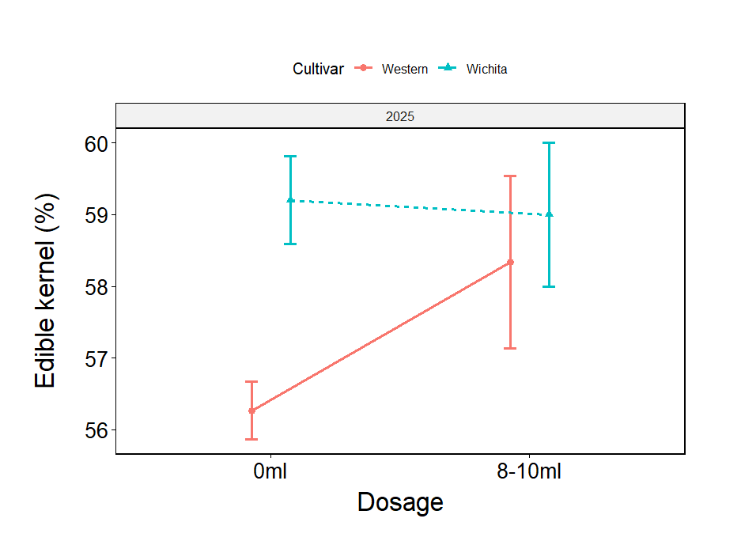

Figure 3. Yield and quality results measured during July 2025 after repeated paclobutrazol applications on two cultivars, Western-Schley and Wichita

Conclusions
Repeated paclobutrazol applications produced cultivar-specific growth and yield responses. Western-Schley showed no significant differences in either reproductive or vegetative shoot lengths during 2024 or 2025, suggesting that its shoot growth was largely unaffected by long-term paclobutrazol treatments. In contrast, Wichita exhibited significantly longer shoots following repeated applications (8–10 ml per tree) indicating a possible stimulatory effect on shoot elongation after several years of treatment.

Stem measurements also varied between cultivars. In Western-Schley, repeated applications significantly increased stem circumference and stem diameter in both measurement seasons. Conversely, Wichita displayed smaller stem diameters in 2024 following treatment, although this difference was not consistent in 2025.

Yield results suggested that long-term paclobutrazol applications had negative effects on production. Western-Schley yields were significantly reduced during the 2023 harvest, while Wichita experienced lower yields in both 2024 and 2025 seasons, despite showing fewer sticktights in 2024. Total yield (natural drop plus sticktights) was also significantly lower for Wichita during both seasons. Importantly, edible kernel percentage remained unaffected across all treatments and cultivars, confirming that nut quality was not compromised by repeated paclobutrazol applications.

Overall, these results demonstrate that while repeated paclobutrazol treatments may promote certain vegetative growth characteristics, particularly in Wichita, it can also lead to reduced yields over time, emphasizing the need for careful dose and frequency management to balance vegetative control and sustained productivity in pecan orchards.

Achnowledgements
Hardus du Toit, Kelebogile Botshelo and Ivan Schubach provided significant support throughout the trial. Dr Elsje Joubert analysed the results. We thank Dries Duvenhage for hosting this trial. Grading reports were provided by Pekanhoek BK.

References
Ahlmann-Eltze, C. & Patil, I. (2021). ggsignif: R Package for Displaying Significance Brackets for 'ggplot2'. PsyArxiv. doi:10.31234/osf.io/7awm6.
Andersen, P.C. (1988), Vegetative and reproductive effects of Cultar applied to ‘Cape Fear’ and ‘Desirable’ pecan trees. Proc. Flo. State. Hort. Soc. 101: 254-256.
Hope, R.M. (2022). _Rmisc: Ryan Miscellaneous_. R package version 1.5.1, <https://CRAN.R-project.org/package=Rmisc>.
Kassambara, A. (2020). _ggpubr: 'ggplot2' Based Publication Ready Plots_. R package version 0.4.0, <https://CRAN.R-project.org/package=ggpubr>.
Kassambara, A. (2021). _rstatix: Pipe-Friendly Framework for Basic Statistical Tests_. R package version 0.7.0, <https://CRAN.R-project.org/package=rstatix>.
Patil, I. (2021). Visualizations with statistical details: The 'ggstatsplot' approach. Journal of Open-Source Software, 6(61), 3167, doi:10.21105/joss.03167.
R Core Team (2015). R: A language and environment for statistical computing. R Foundation for Statistical Computing, Vienna, Austria. URL https://www.R-project.org/.
Wickham, H. (2016). ggplot2: Elegant Graphics for Data Analysis. Springer-Verlag New York.
Wood, B.W. (1988). Paclobutrazol suppresses vegetative growth of large pecan trees. HortScience 23: 341-343.
Zhu, H. & Stafne, E.T. (2019). Influence of paclobutrazol on shoot growth and flowering in a high-density pecan orchard. HortTechnology 29: 210-212.

